Lehmann.anton@bluewin.ch, secretary of the Swiss section of Swaythling-Club (SCS)
On behalf of gloriawagsci67@web.de (Gloria Wagner, Lochnerstr.14, DE-40878 Ratingen, Germany; Copy goes to: Eberhard & Diane Schöler: e.d.schoeler@mail.isis.de

SCI News Nr. 106

Two annual meetings of the Swiss section of Swaythling Club took place successively. The first on November 10th, 2018 in Zurich and the second on February, 2nd 2019 in Montreux

SCS annual meeting of 10.11.2018 in Zurich

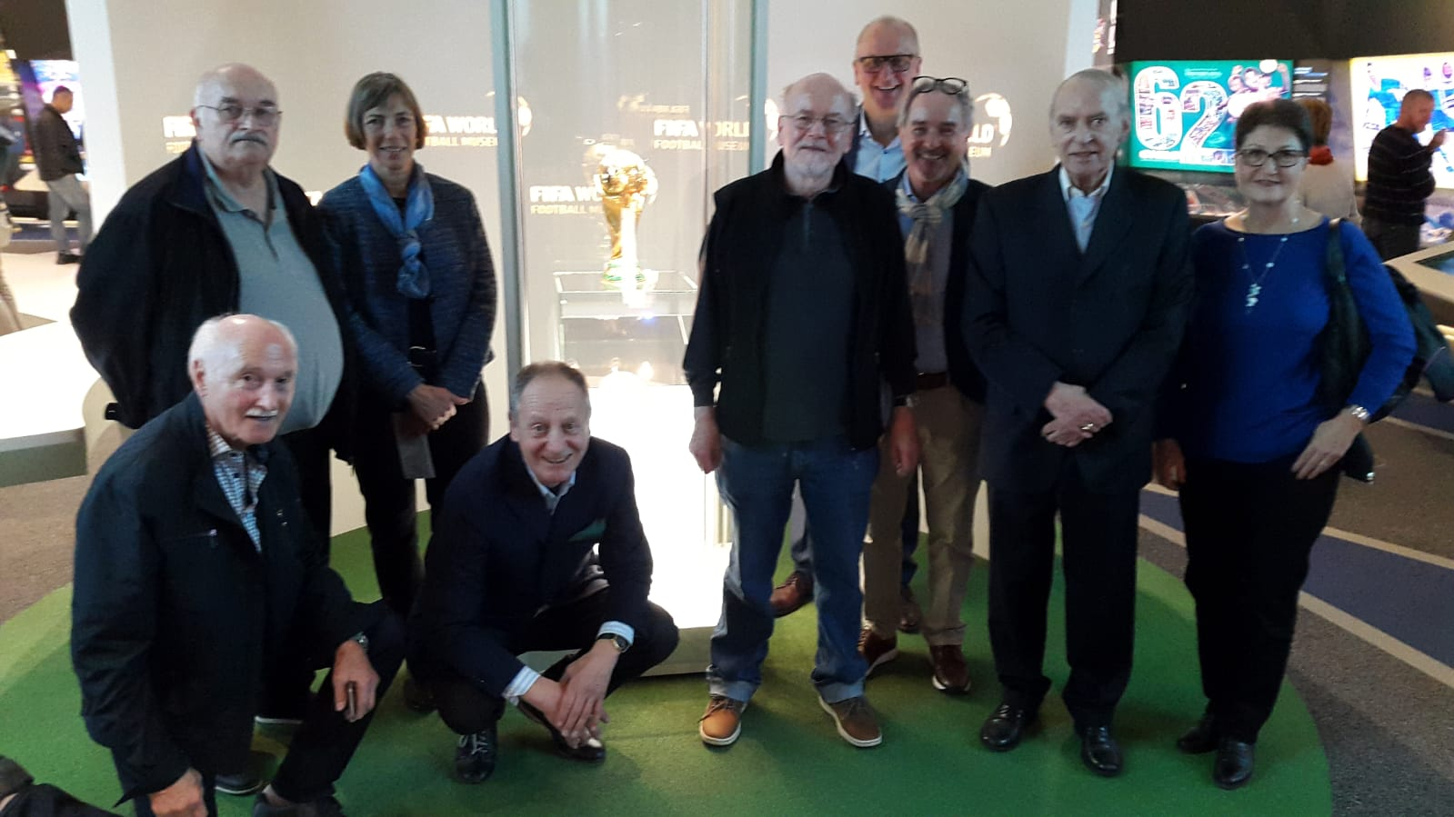

From left: Louis Fiedler, Claude Diethelm, Gaby Persy (life partner of Louis Fiedler), Thomas Sadecky, Anton Lehmann, Thomas Busin, Erwin Heri, Werner Schnyder, Elmira Antonyan-Brunner (photo taken in front of the famous FIFA-Trophy in the FIFA-Museum in Zurich)

al/At the annual meeting of SCS in 2018, President Thomas Sadecky welcomed the members to the stylish FIFA Museum in Zurich, where he competently guided them through the exhibition after a welcome aperitif. After a short walk to the restaurant Bederhof, the official part of the annual meeting was held there. The General Meeting was conducted in accordance to agenda items. Long-time SCS secretary Werner Schnyder has stepped down. He is dismissed with thanks for his merits. Anton Lehmann succeeds him as secretary. The proposal of Thomas Busin to hold the next annual meeting as part of the Top 16, the international TT-tournament in Montreux, was positively received. The final culinary part was used as always for exchange and socializing.

SCS annual meeting of 02.02.2019 in Montreux on occasion of CCB Europe Top 16 Cup

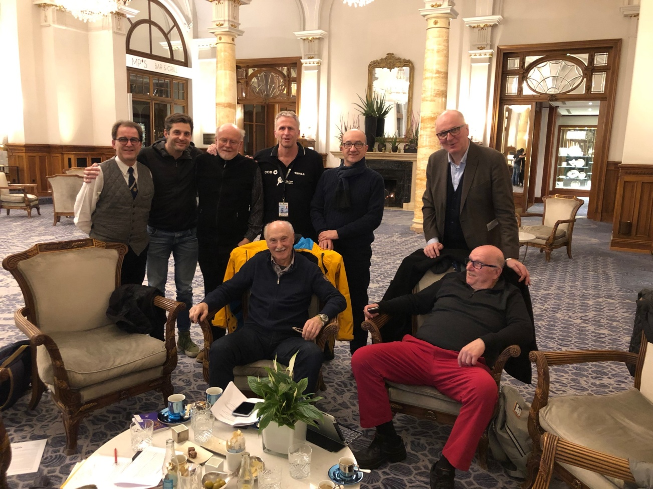

From left: Reto Bazzi, Beat Staufer, Anton Lehmann, Georg Silberschmidt, Nenad Stevanovic, Thomas Busin; sitting: Louis Fiedler, Bernard Chatton

al /Montreux is known for two major international events. The international jazz festival and now, since last year, the international table tennis tournament Europe Top 16 Cup. Georg Silberschmidt, secretary general of this tournament, together with Thomas Busin, invited the Swiss members of Swaythling-Club to the prestigious event in Montreux, on the shores of lake Geneva. Beside admiring highest level of table tennis, Silberschmidt presented a few background information on the CCB Europe Top 16 Cup in Montreux. He outlined the history of the tournament, which already enjoys an excellent reputation in Europe and is, as a matter of fact, supported for three years by the China Construction Bank as title sponsor. In addition, the public sector (community of Montreux, the state of Vaud, Sport-Toto) and various private sponsors (Liebherr, Hotel Fairmont, TT-equipment outfitter) are profoundly involved by promoting table tennis. Considerable spectator interest goes along with print and electronic media coverage such as TV-Eurosport. Next edition of CCB Europe Top 16 Cup will take place on 8./9. of february 2020 in Montreux. Swaythling-Club Switzerland expresses its thanks to the organizers, e.g. free entry in the VIP sector.

